Avoid A Contaminated Christmas
December 2, 2017
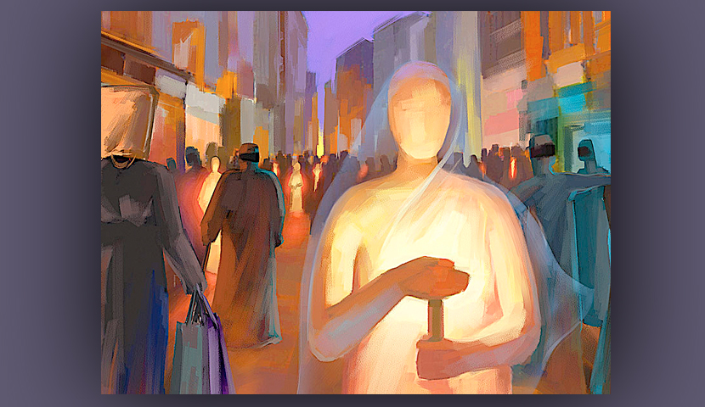
Lord Jesus, please keep us in Your peace and free from contamination, as the world is so full of temptations right now. Amen

Well, dear Heartdwellers, I have been very dry lately in prayer, but tonight during worship, Jesus did reconnect with me and we discussed what has drawn me away from Him lately.

I told Him how dry I felt and I missed Him.

He answered me, "You’ve been in the world, Clare. It strips you of that sweet, spiritual coating that surrounds and protects you and so the world is grating against your spirit. The more time you spend there the more you lose your orientation.

“'The wise mother fox only leaves her den in cases of pressing necessity and returns home immediately.'"

That's a beautiful expression of the Desert Fathers, the very Early Church.

Jesus continued, "You linger out there, because it is disorienting and so many things nail your attention. Precious babies and kitties, fascinating titles and stories. Oh, it is so seductive!

"You know this, but overlook it when you go out. You cannot afford to overlook it, because it sinks its hooks into your flesh and calls you back again and again. It is best for you to pray protection over your time there, because the forces on the Internet, the unseen forces on the Internet, are very psychologically powerful. Forces you know nothing of, but your soul is exposed to. You are there to make it serve you, but when you lose track of that and fall into the intoxicating fascinations of the world, you forget—and that’s when you are stripped of your spiritual covering and protection.

"But you are here now, and I am oh, so happy to have you here by My side and fully aware of My presence once again, Clare. I want to restore your peace, your spiritual buffer, your perspective, your hope and your joy. The electronic venue steals this from you if you linger there. Demons inhabit the Net, Clare. Remember what I told you when you first began your website? 'You are going behind enemy lines.'”

Wow! I do remember that. I had a vision of a little girl in a pink party dress, coming down from an airplane. Her little dress came out like a parachute, and she dropped into the forest behind enemy lines.

He replied, “Yes, and you were so vulnerable. Anyone who works with the Internet is. The secret is to dwell in the Vine and not allow yourself to dwell in curiosities for even a moment."

Remain in Me, and I will remain in you. Just as no branch can bear fruit by itself unless it remains in the vine, neither can you bear fruit unless you remain in Me. It's John 15:4 He's quoting.

Jesus continued, “You really do need to pray for protection every time you go there. I do have angels in place that are doing nothing, but would love to help you. The same way you ask for protection over your dreams, ask them to protect you on the Internet.”

Then He smiled at me and said, "May I have this dance?" The worship music was playing in the background, and He wanted to change the subject. So, I went back into meditation and just being with Him.

After a while, He began again and said, “Thank you for praying, Heartdwellers. My Father is listening most intently to your requests. Keep them specific and numerous, for My Spirit is speaking to the hearts of each one and placing there a vital concern for your intercession. Your prayers are working.

"So much is going on behind the scenes that you know nothing of right now, but in the future, you will see corruption was broken open from November 29th to December 20th. These are key dates to remember when actions were taken. You will see that much you are praying for right now has been answered. It is important for you to see this to understand that YOU make a difference.

"Remember, also, to focus on the abused children, as well, when you pray. So many have been scarred for life, and the ones with Me are far better off. Yet, your prayers can be turned into graces for the survivors, and that more would come forward to disclose these atrocities for convictions of the guilty.

"Your President is doing precisely what I have asked of him, and each day he draws closer and closer to Me, understanding My ways and My wisdom. This, too, is because of your prayers.

"Well, understand, this is also that time of year when assignments are sent out to cause people to feed off the world like sharks in a feeding frenzy. After a while, there is no conscience left and it’s just buy, buy, buy.

"Warn them, Clare. Giving is healthier than having, sharing more rewarding than hoarding, moderation is much better than overkill. Know that this is a massive assignment against those who will cater to their flesh.

"Please, My people, belong to Me, not the world."

Lord, I know you are trying to capture my heart again…which is absolutely tragic that I have wandered so far. The world is constantly drawing my attention. I know we are to pray for the President, but what we have found out so far is sticking in my head, and drawing me into distraction, even in prayer. It is so heinous.

Jesus, how can I make my indifference and carelessness up to You?

"Clare, what I am wanting right now, more than anything, is your commitment to stop and not return to your vomit."

Quoting Proverbs, He said "As a dog returns to his vomit, so a fool repeats his folly." Proverbs 26:11

I answered Him, 'This is on my heart and the heart is willing, but the flesh is weak. How can I predict my behavior?'

He replied, "Cleave to Me. Find your joy in Me. Scorn the world and its empty promises. Refocus, My Dearest Clare, refocus. You are in a battle of the mind right now, as is every other American believer and many around the world. This is the time of the year that sinful excesses take place and it is fueled by curses and demons, who are doing their best to divert people’s attentions to personal gain, greed and materialism.

"But you are not under the influence of either if you choose not to be. It is totally up to you. Refocus. I know it’s hard, because the enemy is shooting arrows at you almost non-stop. Pray against it. Take up your weapons of war; be sure your helmet of salvation is secure. How is it that you can teach these things, but when it comes to practicing it, you are so lame?"

You are right, Lord. I need to be more aggressive against these monsters and their seductive ways with the world’s entrapments.

"Much more aggressive," He replied. "The problem is you still have a bent and a panther dragging you down; you can handle both with prayer. When you still have an attraction to the world and things, it eats at you on and off, trying to get you to give in—because it is fueled by a demon whose only intention is to bring you down. You are not going to do that, but the temptation is still there, because there is still an attraction inside of you. And dealing with it is a distraction.

"As you cleave more and more to Me, Clare, that attraction will fade and, of course, the greed and avarice which has been set loose is going to stop soon after Christmas, if not before, depending world events.

"My precious Heartdwellers, beware of the enemy’s plans to cause you to spend money unnecessarily. What follows when you fall is guilt and debt. You have a very real enemy egging you on.”

“Resist the devil and he will flee from you.” James 4:7

"Knowing this, you can become more circumspect about what you really need and don’t need. Please do not detract from celebrating My birth by making it a materialistic free-for-all. Please honor Me as the center and teach your children, by example, holy values."

Lord, how do I handle Christmas decorations and the advent wreath without being worldly?

"Keep it simple and centered on Me. I didn’t say you couldn’t put a few decorations up. This is the time of the year that little children remember, when they grow older, as being festive and very special. Since you have a child in the house almost every day, think of her when you put things up. Yet, keep it simple."

And on that note, we have a baby basket and baby Jesus with straw and our tradition is to put Baby Jesus in the basket on Christmas Eve. And a few other things we had in our chapel to celebrate His birth, as well.

When my children were little, they made corn husk saints…those who gave their lives as a present to Jesus. We hung them on a large sage bush above baby Jesus. It was very special, because we all made them according to the Bible’s description. We had Moses, Elijah, John the Baptist, Mary and Joseph. St. Francis & St. Clare and many others. This was a sweet, creative project that involved scraps and really no money at all, but was so very special. And got the point across that it's about giving ourselves to Jesus, just as He gave Himself to us.

Well, I wanted to mention, dear ones. On the domestic front. I got some help cleaning out my drawers to see exactly what needed mending, dying, cleaning or whatever, to take the place of my foolishness in wanting something new. By the time we got done, I had more than enough clothing to be practical, and had I known that in the first place, I never would have considered spending even a little on clothing. I’m sure we’ll find shirts tomorrow.

Funny—or not so funny—how we allow ourselves to be led off course. I wanted to tell you this, because the Lord was totally justified in saying “no” to me. He was not acting harshly or depriving me at all. He knew I had enough clothing with a little mending. So, you see, my big fit was totally, demonically inspired from start to finish, and as usual, the devils prove themselves to be liars... again.

We are praying for President Trump, covering him with prayer and his cabinet as well, that everything he puts his hand to will succeed and the rotten-to-the-core Deep State government will come down. It is more than likely that they have something planned, some kind of event to cause a disruption to the arrests that are taking place, to get people's attention over who's being arrested and why. So, be prepared.

Those of you who have been so kind to us, keeping us going, thank you so very much for your donations. Your love and giving has greatly encouraged us and again shown us that the Lord has hand-picked you all to be here because your hearts are for Him.

So, let us hold to the hope we have in Him.

...Let us draw near with a sincere heart in full assurance of faith, having our hearts sprinkled to cleanse us from a guilty conscience and our bodies washed with pure water. Let us hold resolutely to the hope we confess, for He who promised is faithful. And let us consider how to spur one another on to love and do good deeds. Hebrews 10:22-24

God bless you, and Amen.

